MEDIA RELEASE |  | FOR IMMEDIATE RELEASE  19 February 2018
POPE CORPSE ON TRIAL - TRUE(ish) STORY
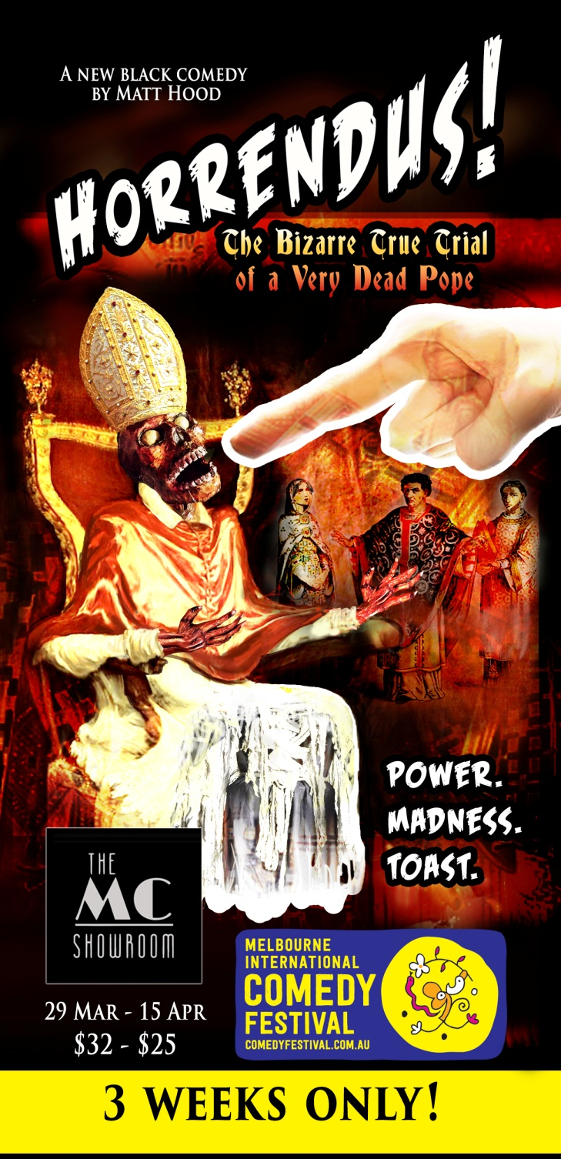  MORE INFO + PRESS IMAGES  www.horrendustheatre.com  www.goldenowlevents.com  PUBLICITY CONTACT  Olivia Duval - 0411 480 709  goldenowlevents@gmail.com | MACHIAVELLIAN MELBOURNE MINDS MAKE NEW COMEDY THEATRE SHOW  "Horrendus!  The Bizarre True Trial Of A Very Dead Pope"  The MELBOURNE INTERNATIONAL COMEDY FESTIVAL gets a dastardly dose of death in this romping black comedy about power, madness and rotting cadavers.  Set when the world nosedived into the Dark Ages and the Roman Empire was but a skid mark of the underpants of history: when rivalry to be the next Pope was at an all-time murderous high.  Long before Blackadder wormed his way into the royal trousers, Cardinal Theodore wrangled the nefarious,  the naughty and the downright deranged in his bid  to wear The Really Big Hat. Then one morning  Pope Stephen IV dragged the rotting corpse of his predecessor from its grave and put it on trial.  Horrendus! Inspired by actual historic events. Yes, really.  SHOW DATES & TIMES  March 8:30 - 10:30pm Thurs 29  Fri 30  Sat 31  April 7pm - 9pm Sun 1  8:30 - 10:30pm Thurs 5  Fri 6  Sat 7  7pm - 9pm Sun 8  8:30 - 10:30pm Thurs 12  Fri 13  Sat 14  7pm - 9pm Sun 15  From the creative team behind the sold-out black comedy show Jack and Jill: The Poisoners of London (2013), Jack and Jill: The Devil Chemists of Whitechapel (2014), and the puppet show The Red Bird and Death (2012).  Written by Matt Hood. Directed and Produced by Emma Buckley. Original score by Mbryo.  Starring Claude Jabbour, Anthony Kuiper, Nichola Vecchiato, Harlene Hercules and Campbell Gruiters.
VENUE: THE MC SHOWROOM Level 1, 48 Clifton Street, Prahran, Melbourne
TICKETS: $32, $25 Concession on EVENTBRITE, MELBOURNE COMEDY FESTIVAL and at the door

MEDIA IMAGES
Please feel free to crop, alter and use these images in any way you wish.
For different formats, higher resolutions or other alterations please contact the Publicity Manager Olivia Duval.

